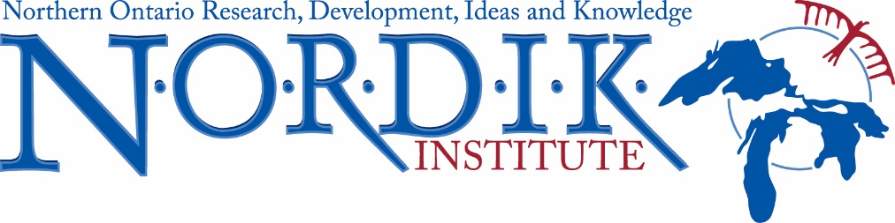

**Programming and Research Assistant Internship**

NORDIK Institute, Algoma University’s community-based research organization, is dedicated to the practice of holistic community development in strengthening Northern Ontario’s resilience. Its is currently seeking a **Programming and Research Assistant intern** to provide support to a number of diverse local and regional initiatives and partnerships currently underway including those with Algoma University’s Shingwauk Residential Schools Centre (SRSC), the Children of Shingwauk Alumni Association, among others.

**Responsibilities & Duties:**

* Assist in the scheduling and delivery of programming, including urban indigenous social economy education;
* Assist with the coordination of meetings: scheduling, preparing meeting packages, sending out notices and taking minutes;
* Assist with coordinating communication between community organizations regarding meetings, consultations, training, and/or events;
* Assist in following up with the documentation and report writing of community consultations, events, etc.;
* Assist with all aspects of research including literature reviews, data collection and analysis and report writing; and
* Attend monthly research meetings and other training workshops provided by NORDIK and university faculty and staff

**Qualifications and Requirements:**

The candidate should possess a degree in Community Economic and Social Development or a degree in another Social Science discipline.

The candidate should possess the following skills:

* Strong communication skills and demonstrated ability to work collaboratively with diverse cultural, geographic and intergenerational partners
* Strong knowledge of a diversity of local Indigenous cultures
* Strong administrative skills including continual priority setting to meet emerging and evolving networks and ideas while meeting project objectives
* Good networking and interpersonal skills
* Good interpersonal skills and ability to work in a team environment
* Experience in event organizing and planning
* Experience in report writing and preparing funding applications.

**Candidate Eligibility:**

* University and college graduates who have graduated within the last three years from an accredited college or university. Candidates must be graduates of post-secondary degree or diploma programs.
* The position must provide the intern with first time employment in their field of study.
* Candidates are only eligible to participate in the internship program one time.
* Candidates must be legally entitled to work in Canada.

**Application Instructions:**

**Applications are due by March 13, 2019.**

This is a one-year contact.

Only candidates considered to be qualified for the position will be contacted for an interview.

 Letters of application and resumes can be mailed or emailed to Lisa Meschino, Manager of Operations and Communications, NORDIK Institute, 1520 Queen St. E. Sault Ste. Marie, ON P6A 2G4.

E-mail:  lisa.meschino@algomau.ca

**This Opportunity is Proudly Supported by:**

