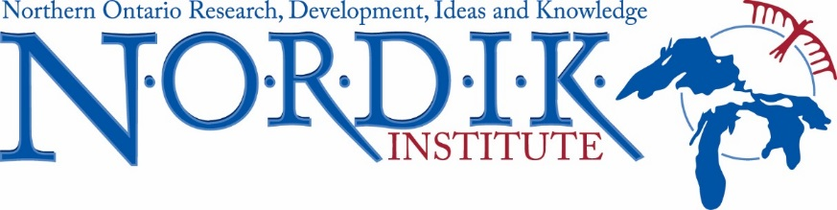

Events Coordinator Intern

NORDIK Institute, affiliated with Algoma University, is seeking an Events Coordinator Intern to support projects in the Timmins region. Specifically, the Intern would continue organizing engagement and training events, and assist in conducting research to identify future growth areas in post-secondary education. The Intern would engage organizations, entrepreneurs and changemakers, students and educators in diverse events including information sessions, workshops, education and training opportunities and conferences, building connections between citizens, business service providers, educators and funders.

Location: This position is located either in Timmins at the Timmins Economic Development Corporation/Business Enterprise Centre or in Sault Ste. Marie at NORDIK Institute. The Director of NORDIK and the Director of Community Development at the Timmins Economic Development Corporation would provide supervision.

Responsibilities and Duties:
- Organize workshops and training to build peoples’ capacity to address local needs through a variety of business solutions;
- Connect people with resources (e.g., toolkits, webinars, workbooks, websites, peer mentors, business professionals; funders)
- Assist with the development of a Northeastern region network between and among community members, entrepreneurs, changemakers, service providers, educators, and funders; and,
- Assist with research activities, including data collection, stakeholder identification, distribution of surveys and coordination of interviews and focus groups.

Qualifications and Requirements:
The candidate should possess a degree in Community Economic and Social Development, Business Administration or a degree in another Social Science discipline, or possess a post-secondary diploma in Event Management.

The candidate should possess the following skills:
- Strong communication skills and demonstrated ability to work collaboratively with diverse cultural, geographic and intergenerational partners;
- Strong administrative skills including continual priority setting to meet emerging and evolving networks and ideas while meeting employment objectives;
- Good interpersonal skills and ability to work in a team environment;
- Experience in meeting and event organizing and planning;
- Demonstrated ability to utilize technology (e.g. webinars, zoom meetings, etc.) in meeting project goals;
- Experience in report writing and preparing funding applications;
- Valid Drivers License;
- Ability to travel frequently within Northeastern Ontario (primarily Timmins area);
- Strong knowledge of a diversity of Indigenous cultures;
- Bilingual (English/French).

Candidate Eligibility:
- University and college graduates who have graduated within the last three years from an accredited college or university. Candidates must be graduates of post-secondary degree or diploma programs.
- The position must provide the intern with first time employment in their field of study.
- Candidates are only eligible to participate in the internship program one time.
- Candidates must be legally entitled to work in Canada.

Application Instructions: On-going until the position is filled
This is a one-year contact. This position is located either in Timmins at the Timmins Economic Development Corporation/Business Enterprise Centre or in Sault Ste. Marie at NORDIK Institute.

Only candidates considered to be qualified for the position will be contacted for an interview.
Letters of application and resumes can be mailed or emailed to Lisa Meschino, NORDIK Institute, 1520 Queen St. E. Sault Ste. Marie, ON P6A 2G4.
E-mail: lisa.meschino@algomau.ca

